Data Management, Analytics and Visualization 26
Project 1: Exploratory Data Analysis of the ANSUR Anthropometric Measure Dataset
Xiaojing Huang
March 3, 2026

1. Introduction
The purpose of this analysis was to examine anthropometric and demographic characteristics in the ANSUR II dataset and to explore relationships between body measurements and body mass index (BMI). Specifically, this project investigated differences by sex, associations between height, weight, and BMI, and how BMI varies across age groups.
The data come from the U.S. Army Anthropometric Survey (ANSUR II), which was conducted between 2010 and 2012. The ANSUR II dataset is a large-scale anthropometric survey conducted between 2010 and 2012 among U.S. Army personnel [1,2]. The database includes 93 directly measured anthropometric variables and 15 demographic variables. The survey collected detailed body measurements from active-duty U.S. Army personnel. Participants were measured using standardized protocols, and the dataset includes both male and female soldiers. The sample used in this analysis includes 7,029 observations. Variables include demographic characteristics such as age and sex, as well as anthropometric measurements such as height, weight, and multiple body dimensions. These measurements allow us to study variation in body size and composition within this military population.
2. Data preparation
2.1 Data Analysis Plan
The purpose of this project is to prepare a clean analytical dataset and conduct an exploratory data analysis on selected anthropometric and demographic variables from the ANSUR II study. The dataset contains measured body dimensions and background information for military personnel. To better understand the meaning, units, and measurement procedures of each variable, the ANSUR II documentation was reviewed, including the Memorandum for Record and the technical report describing the measurement methods.
The overall data preparation plan was completed in several steps. First, I inspected the dataset for missing values, unreasonable values, and duplicate observations. Second, I recoded missing values according to the codebook. Third, I created all required derived variables, including BMI, BMI category, season of measurement, body type, and (for PBHLT 7101) t-shirt size. Finally, I ensured that all variables were clearly labeled and that categorical variables had appropriate value labels [3].
2.2 Missing Values
According to the ANSUR II documentation, missing values were coded using negative numbers. The values -77 indicated that a measurement was not recorded, -88 indicated refusal, and -99 indicated unknown missing. All numeric variables were scanned for these codes and were recoded into Stata special missing values (.a, .b, and .c). After recoding, summary statistics were reviewed to confirm that missing values were handled correctly and no negative placeholder values remained in the dataset.
2.3 Suspect and Unreasonable Values
All variables were examined using summary statistics and logical checks to identify potentially unreasonable values. Particular attention was given to height, weight, and BMI. Extremely large BMI values and unrealistic stature values outside typical adult ranges were flagged. Instead of deleting these observations automatically, a binary indicator variable was created to identify cases with suspect values. This approach allows these observations to be evaluated later in the analysis without permanently removing them.
2.4 Duplicate Observations
Potential duplicate observations were identified using combinations of subject identifier, measurement date, gender, height, and weight. The Stata duplicates command was used to tag these records. A separate flag variable was created to indicate possible duplicates. Duplicate records were saved in a separate dataset for documentation. When identical records were confirmed, the first occurrence was retained and additional identical entries were removed to prevent double counting.
2.5 Age Restriction
The ANSUR II documentation indicates that participation was limited to individuals aged 18 years or older. Therefore, all observations with age less than 18 were identified and removed from the analytical dataset. Before removal, these observations were saved in a separate file for documentation purposes. The final analytical dataset includes only eligible adult participants.
2.6 Unit Conversion
The codebook indicates that measured body lengths were recorded in millimeters. For easier interpretation, all relevant length measurements were converted from millimeters to centimeters by dividing by 10 and creating new variables with a “_cm” suffix. Measured weight was also reviewed carefully because the documentation indicates it may be recorded as kilograms multiplied by 10. Descriptive statistics were examined to confirm that weight values were in a reasonable adult range before calculating BMI.
2.7 Creation of New Variables
A unique identifier variable was created to ensure that each observation had a distinct key.
Body mass index (BMI) was calculated using the standard formula weight in kilograms divided by height in meters squared. A categorical BMI variable was also created [3]: underweight (BMI less than 18.5), normal weight (18.5 to 24.9), overweight (25.0 to 29.9), and obese (30.0 or greater).
A season variable was created based on the month of measurement. Winter was defined as December through February, spring as March through May, summer as June through August, and fall as September through November.
Gender and preferred hand were originally stored as string variables. These variables were converted into numeric categorical variables using the encode command, and value labels were applied.
Body type categories were created using combinations of height and BMI. Within each gender, height and BMI were divided into three groups. These groupings were combined into five body type categories representing different body builds. This method allows classification of body type while accounting for differences between men and women.
For PBHLT 7101, a t-shirt size variable was created based on chest circumference in centimeters. Cutpoints were determined using a standard unisex sizing chart[5]. The categories included XS, S, M, L, XL, and XXL.
2.8 Final Analytical Dataset
All newly created variables were labeled clearly, and categorical variables were assigned value labels. Special missing values were preserved. The final dataset includes original variables, recoded missing values, derived variables, and indicator flags. This cleaned dataset will be used for the subsequent exploratory data analysis.

3. Anthropometric Characteristics

3.1(a) Description of Anthropometric Measures
The anthropometric characteristics of the sample are presented in Table 3.1-1. After data cleaning, the final sample included 7,029 participants. For most anthropometric variables, only one observation was missing.
The mean measured height (stature) of the sample was 171.7 cm (SD = 9.0), with values ranging from 141 cm to 199 cm. The mean arm span was slightly larger at 176.8 cm (SD = 11.1). Functional leg length averaged 110.4 cm, and knee height averaged 47.5 cm. These values appear reasonable and consistent with expected adult body dimensions.
For trunk measurements, the mean chest circumference was 102.5 cm (SD = 10.0), and the mean hip breadth was 34.8 cm. Bicristal breadth averaged 27.5 cm. These measurements show moderate variability but fall within expected ranges for adults.
The average measured body weight was 80.0 kg (SD = 15.6), with values ranging from 36 kg to 144 kg. Overall, the anthropometric measures appear plausible after correcting data entry errors and converting all length measures from millimeters to centimeters.
No large amounts of missing data were observed, and extreme values were reviewed and corrected when appropriate. The distributions of the variables were consistent with expected adult military populations.
Table 3.1-1. Anthropometric characteristics of the study sample (N = 7,029)
Group | Varname | N | N_miss | N_suspect | Mean | SD | Min | Max
Self-reported | heightin | 7029 | 0 | 1 | 68.35 | 3.85 | 56 | 94
Self-reported | weightlbs | 7029 | 0 | 1 | 175.46 | 33.60 | 0 | 321
Stature/Length | cervicaleheight(cm) | 7028 | 1 | 0 | 147.98 | 8.41 | 118 | 174
Stature/Length | footlength(cm) | 7028 | 1 | 0 | 26.34 | 1.73 | 20 | 32
Stature/Length | functionalleglength(cm) | 7028 | 1 | 0 | 110.43 | 6.81 | 84 | 132
Stature/Length | kneeheightmidpatella(cm) | 7028 | 1 | 0 | 47.53 | 3.29 | 35 | 61
Stature/Length | span(cm) | 7028 | 1 | 0 | 176.79 | 11.05 | 132 | 212
Stature/Length | stature(cm) | 7028 | 1 | 0 | 171.66 | 8.97 | 141 | 199
Stature/Length | thumbtipreach(cm) | 7028 | 1 | 0 | 79.24 | 5.34 | 60 | 100
Stature/Length | trochanterionheight(cm) | 7028 | 1 | 0 | 88.28 | 5.40 | 66 | 110
Stature/Length | waistheightomphalion(cm) | 7028 | 1 | 0 | 103.26 | 6.25 | 81 | 125
Trunk | bicristalbreadth | 7028 | 1 | 0 | 27.45 | 1.91 | 20 | 36
Trunk | chestcircumference(cm) | 7028 | 1 | 0 | 102.49 | 10.02 | 70 | 147
Trunk | hipbreadth(cm) | 7028 | 1 | 0 | 34.84 | 2.50 | 26 | 47
Trunk | hipbreadthsitting(cm) | 7028 | 1 | 0 | 38.59 | 3.20 | 28 | 54
Weight | weight(kg) | 7028 | 1 | 0 | 80.02 | 15.62 | 36 | 144
3.1(b) Hip Height as a Percentage of Total Stature by Sex
The percentage of total height attributable to hip height was calculated by dividing trochanterion height by total stature and multiplying by 100. This value represents the proportion of overall body height that is accounted for by lower body length.
Figure 3.1-1 shows the distribution of this percentage by sex. On average, males had a slightly higher percentage compared to females, indicating that a greater proportion of total height was attributable to hip height among males. However, the difference between the two groups was relatively small. The variability within each sex was also similar, suggesting that the overall body proportion pattern was broadly comparable across sexes.
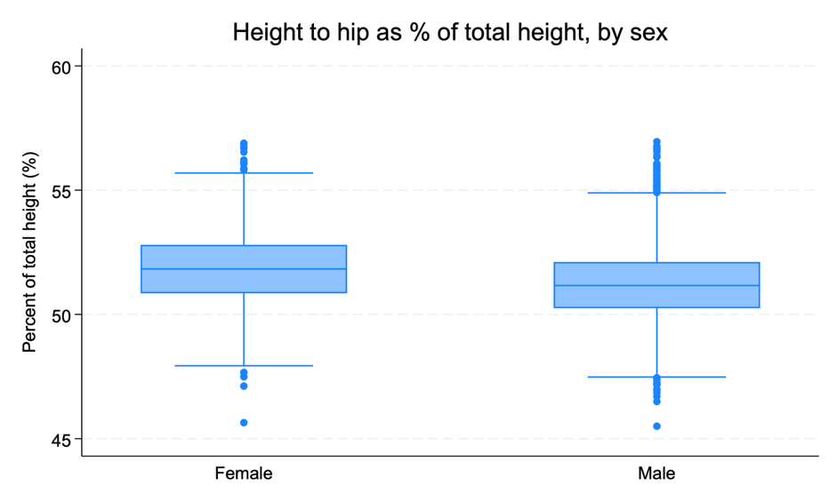
Figure 3.1-1. Height to hip as a percentage of total stature by sex
Overall, the results suggest modest differences in body proportions between males and females, but no extreme divergence in the relative contribution of hip height to total stature.

3.2 Data Quality Assessment
During data preparation, I carefully reviewed the dataset to identify possible data quality problems and to make sure the variables were coded correctly. After applying all cleaning steps, the final analytical sample included 7,029 participants.
First, I found that missing values were coded using negative numbers (-77, -88, and -99). These were recoded into Stata special missing values so that they would not affect calculations. After recoding, I confirmed that no placeholder negative values remained in the dataset.
Next, I examined the anthropometric variables for unrealistic or extreme values. Because all participants were adults, I reviewed height, weight, and BMI to check whether any values were outside a reasonable adult range. A binary flag variable was created to identify potentially suspicious observations. In total, 40 observations were flagged as having at least one potentially suspicious value. These cases were not automatically removed, but were kept and clearly marked so they can be reviewed if needed.
I also checked for duplicate observations using subject identifier, measurement date, and key body measurements. No exact duplicate records were found in the final dataset. In addition, I created a separate indicator variable to flag possible duplicate cases for documentation purposes, but no observations met the criteria.
In addition, I verified the age requirement. Because the study only included individuals aged 18 years or older, I confirmed that all observations in the dataset met this requirement.
Finally, I confirmed the measurement units. Body measurements were originally recorded in millimeters, so they were converted to centimeters in the final dataset to improve clarity. Weight values were also checked before calculating BMI to ensure they were within a reasonable range.
Overall, only a small proportion of the dataset (40 out of 7,029 observations) required flagging, and the data appeared generally consistent after cleaning. All steps were documented in the Stata program to ensure that the process is reproducible.
4. Relationships between anthropometric measures

4.1(a) Relationship Between Measures of Stature
The correlation matrix showed strong positive correlations among all measures of stature. All correlation coefficients were statistically significant (p < 0.001). This indicates that the different measurements of vertical body dimensions are closely related in this sample.
The strongest correlation was observed between overall stature and cervicale height (r = 0.991). This very high correlation is expected because both measurements represent vertical body length and are anatomically closely related. According to the ANSUR II Technical Report, cervicale height is measured from the floor to the cervicale landmark located at the base of the neck, which explains its close relationship with total stature.¹
Other measures, such as waist height (r = 0.936) and knee height (r = 0.889), were also highly correlated with overall stature. These results suggest that the various anthropometric measures of stature capture similar aspects of body size and scale proportionally across individuals.
Figure 4.1-1 illustrates the strong linear relationship between stature and cervicale height. The scatterplot shows an almost perfectly linear trend, with very little deviation from the fitted regression line.
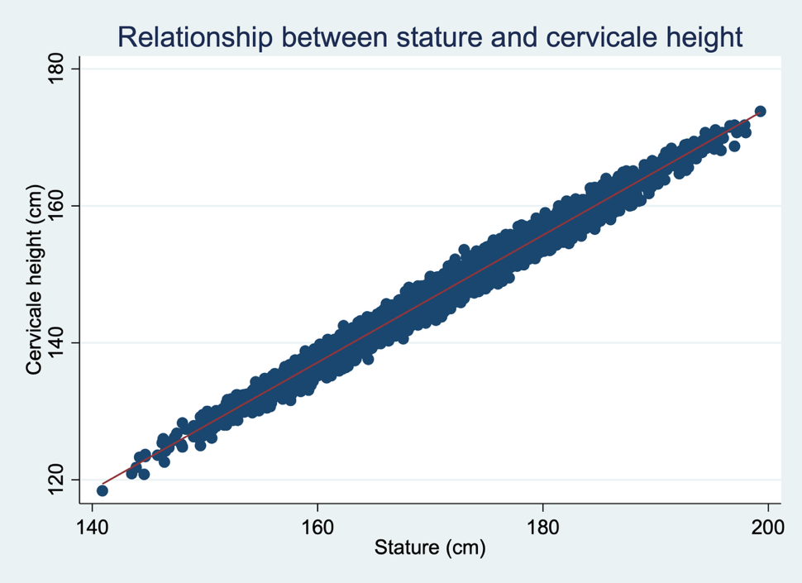
Figure 4.1-1. Relationship between stature and cervicale height

4.1(b) Correlation Between Stature and Other Measures by Sex
Table 4.1-1 presents the correlation coefficients between overall stature and other measures of stature, stratified by sex. In both women and men, all stature-related measures were strongly and positively correlated with overall height (all p < 0.001).

Table 4.1-1 Correlation between stature and other stature measures, by sex
Measure | Female (r) | Male (r)
Knee height | 0.8406 | 0.8335
Cervicale height | 0.9845 | 0.9840
Trochanterion height | 0.8586 | 0.8527
Waist height | 0.9097 | 0.9074
Functional leg length | 0.8316 | 0.8123
Foot length | 0.7251 | 0.7169
Thumbtip reach | 0.6712 | 0.6922
Arm span | 0.8202 | 0.8226
For women, the strongest correlation with stature was observed for cervicale height (r = 0.985), followed by waist height (r = 0.910). Similar results were found for men, where cervicale height also showed the highest correlation with stature (r = 0.984), followed by waist height (r = 0.907).
The magnitude of the correlations was very similar between women and men across all measures. Measures representing vertical body dimensions, such as cervicale height and waist height, showed the strongest associations with overall stature. In contrast, more distal measures such as foot length and thumbtip reach showed comparatively lower correlations.
Overall, the pattern of association between stature and other anthropometric measures was consistent across sexes, indicating that proportional relationships among vertical body measurements are similar in women and men.

4.2(a) Comparison Between Self-Reported and Measured Weight
The difference between self-reported and measured weight was calculated as reported minus measured weight. The mean difference was −0.43 kg (SD = 3.34 kg), indicating that, on average, participants slightly underreported their body weight. The median difference was −0.24 kg, which suggests that the typical discrepancy between reported and measured weight was small.
Most observations were clustered within a few kilograms of zero, as shown in Figure 4.2-1. The histogram demonstrates that the majority of individuals reported their weight reasonably accurately. However, several extreme values were observed, with differences as large as −88 kg and +66 kg. These extreme discrepancies likely reflect data entry errors or implausible self-reports.
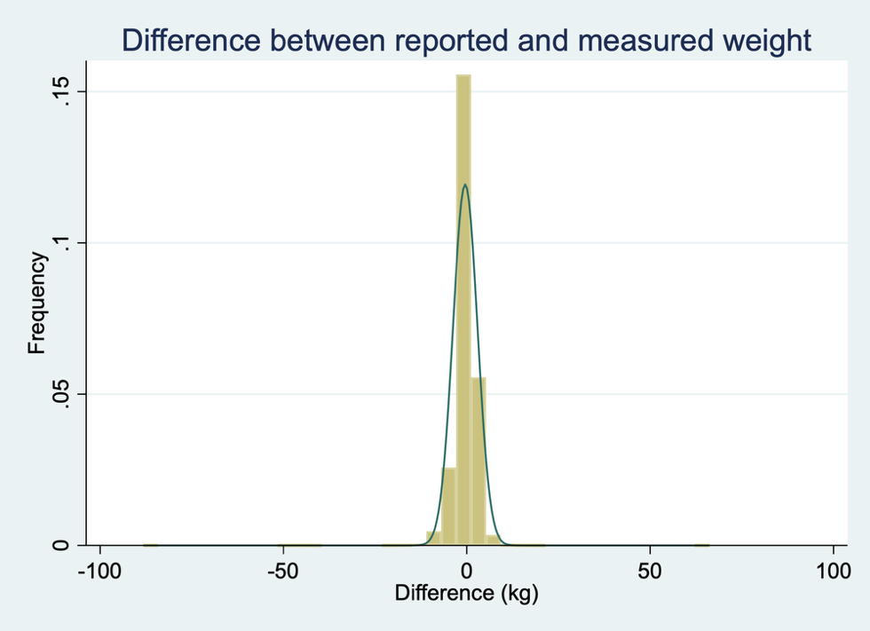
Figure 4.2-1. Distribution of the difference between self-reported and measured weight
Overall, the results suggest a small systematic underreporting of body weight, although the magnitude of the bias appears modest for most individuals.

4.2(b) Sex Differences in Reporting Bias
The difference between self-reported and measured weight was examined separately for men and women. Among men (n = 4,846), the mean difference was −0.25 kg (SD = 3.61 kg), indicating a very small average underreporting of body weight. The median difference was −0.05 kg, suggesting that for most men, reported weight was very close to measured weight.
Among women (n = 2,182), the mean difference was −0.83 kg (SD = 2.63 kg), indicating a larger average underreporting compared to men. The median difference was −0.56 kg, which further suggests a consistent tendency among women to report slightly lower body weight than measured.
Figure 4.2-2 illustrates the distribution of reporting differences by sex. While both groups showed small overall discrepancies, women demonstrated a greater degree of systematic underreporting. Extreme values were present in both groups, but most observations were clustered near zero.
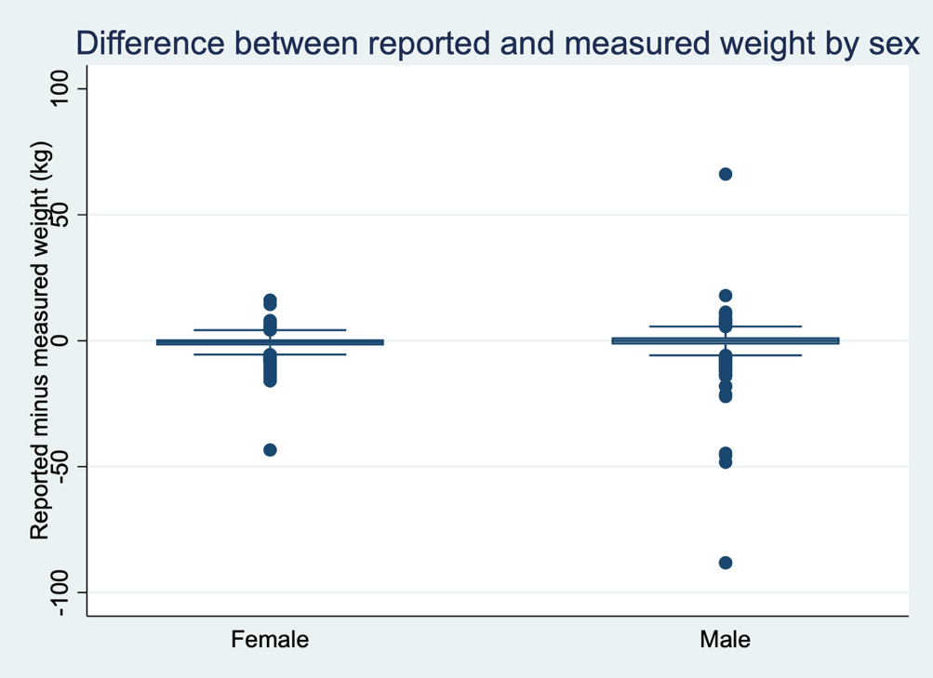
Figure 4.2-2. Difference between self-reported and measured weight by sex
Overall, the results suggest that self-reported weight introduces a small downward bias, particularly among women.

4.2(c) Comparison Between Self-Reported and Measured Height
The difference between self-reported and measured height was calculated as reported minus measured height. The mean difference was +1.94 cm (SD = 2.81 cm), indicating that participants tended to overreport their height. The median difference was 1.78 cm, suggesting that most individuals reported being approximately 1–2 cm taller than their measured stature.
The distribution of differences is shown in Figure 4.2-3. Most observations were clustered between 0 and 5 cm, reflecting a consistent pattern of slight overreporting. However, several extreme values were observed, with differences exceeding ±20 cm. These extreme discrepancies likely reflect data entry errors or implausible self-reports.
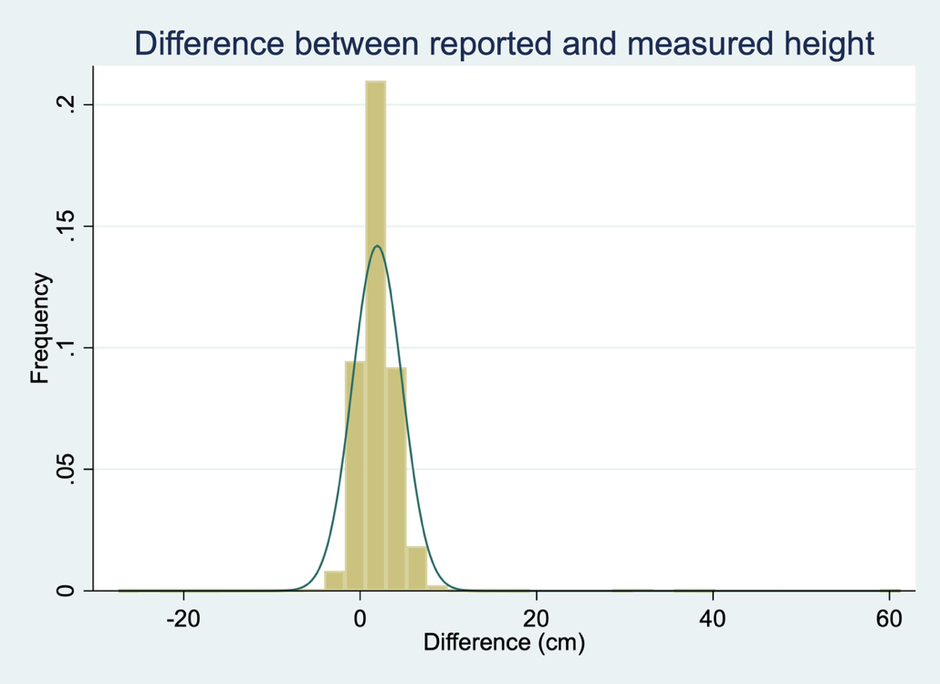
Figure 4.2-3. Distribution of the difference between self-reported and measured height
Overall, self-reported height demonstrates a clear upward bias relative to measured height.

4.2(d) Summary of Reporting Bias
Across analyses, self-reported anthropometric measures showed systematic bias compared to measured values. Self-reported weight demonstrated a small downward bias, with participants underreporting weight by an average of 0.43 kg. This bias was more pronounced among women (−0.83 kg) than men (−0.25 kg).
In contrast, self-reported height showed a clear upward bias. On average, participants overreported their height by approximately 1.94 cm. This pattern is consistent with common reporting tendencies, where individuals slightly underestimate their weight and overestimate their height.
Because BMI is calculated using both weight and height, even small systematic differences can influence obesity classification. Overreporting height combined with underreporting weight may lead to an underestimation of BMI and, consequently, an underestimation of overweight or obesity prevalence when using self-reported data. These findings suggest that measured anthropometric values provide more accurate estimates for epidemiologic research.

4.3 Relationship Between Derived Body Type and Weight/BMI
Body types were created based on height and BMI categories. To assess whether these derived body types meaningfully differentiate individuals by body size, the distributions of measured weight and BMI were compared across groups.
As shown in Table 4.3-1 and Figures 4.3-1 and 4.3-2, clear differences were observed across body types. Individuals classified as short + lean had the lowest average BMI (22.8 kg/m²) and lowest mean body weight (61.8 kg). In contrast, those categorized as tall + heavy had the highest mean BMI (31.3 kg/m²) and highest mean weight (100.6 kg).
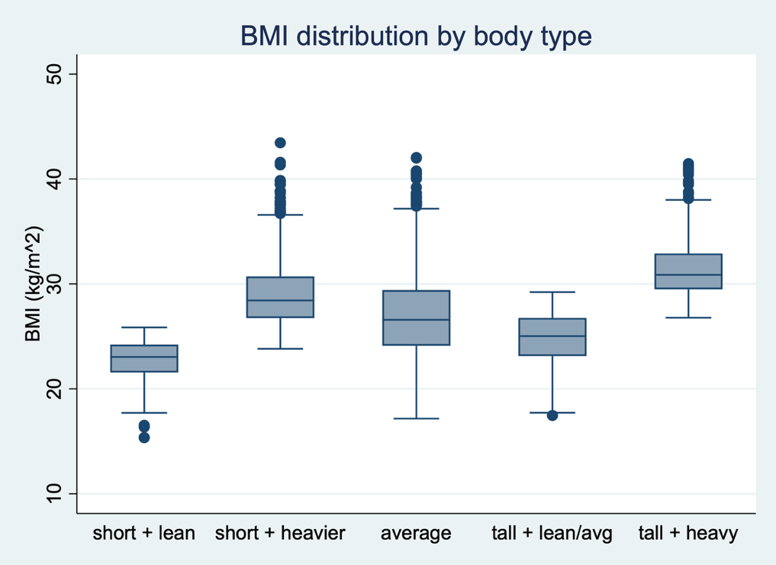
Figure 4.3-1. BMI distribution by body type
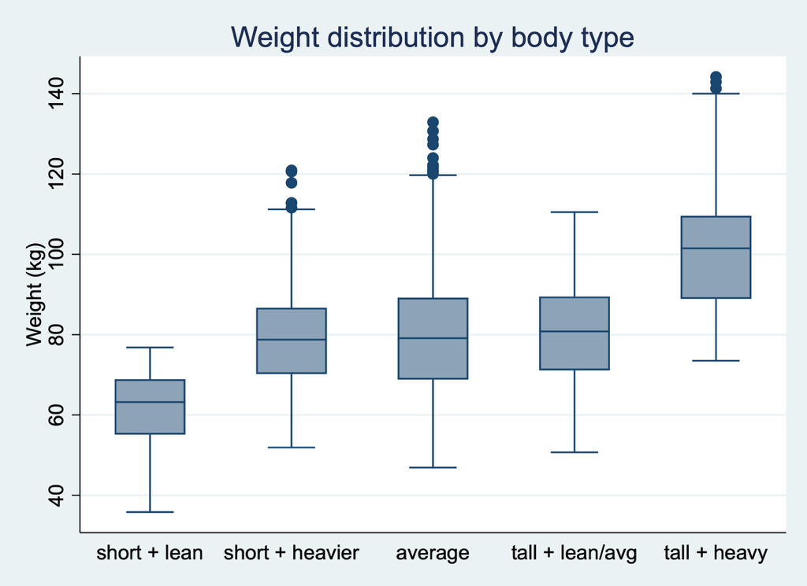
Figure 4.3-2. Weight distribution by body type
Participants in the short + heavier group had a mean BMI of 29.0 kg/m², which was higher than the “average” group (26.9 kg/m²) and the “tall + lean/avg” group (24.9 kg/m²). The boxplots further demonstrate that BMI increases consistently across groups from lean to heavier categories. The separation between groups is especially clear for BMI, indicating that the derived body type classification captures meaningful differences in obesity status.
Overall, the results suggest that the constructed body type variable successfully differentiates individuals by both body weight and BMI. In particular, the “tall + heavy” and “short + heavier” groups show substantially higher BMI values, supporting the validity of the classification scheme.
5.Relationships of demographic characteristics and BMI.
5(a)
BMI was positively associated with age for both females and males (Figure 5a). Among females (n = 2,182), each additional year of age was associated with an increase of 0.10 BMI units (β = 0.099, p < 0.001). Among males (n = 4,846), each additional year of age was associated with an increase of 0.12 BMI units (β = 0.121, p < 0.001). The association was statistically significant in both groups. However, the R-squared values were relatively small (5.7% in females and 7.3% in males), suggesting that age explains only a small proportion of the variation in BMI. Overall, BMI tends to increase slightly with age in both sexes, and the slope appears somewhat stronger among males.
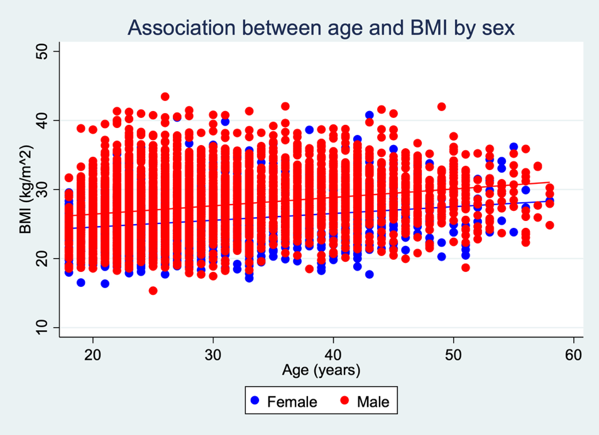
Figure 5a. Association between age and BMI by sex
5(b)
When age was categorized using standard NCHS age groups [4], BMI increased across age categories in both females and males (Figure 5b).
Among females, the mean BMI was 24.61 in ages 18–24, 25.88 in ages 25–44, and 27.05 in ages 45–64.
Among males, the mean BMI was 26.27 in ages 18–24, 28.30 in ages 25–44, and 29.04 in ages 45–64.
In both sexes, BMI was lowest in the youngest group and highest in the 45–64 group. Males consistently had higher than females within each age category. The boxplots show a gradual upward shift in the BMI distribution with increasing age.
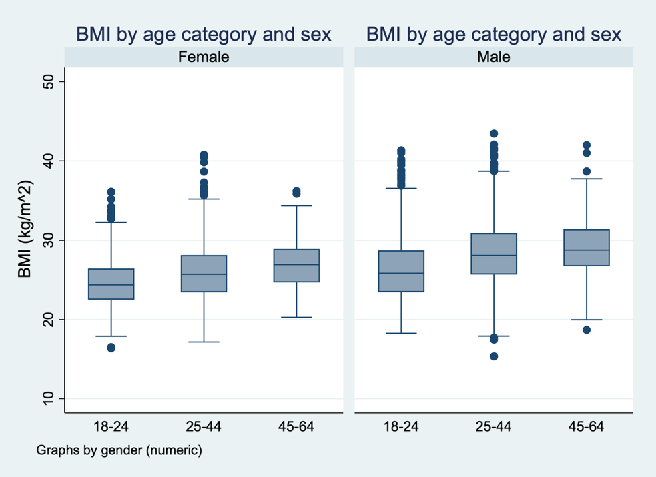
Figure 5b. BMI by age category and sex
5(c)
The continuous analysis in part (a) provides a precise estimate of how BMI changes per year of age. It allows us to quantify the association and test statistical significance directly. However, the effect size per year is relatively small and may be less intuitive for interpretation.
In contrast, the categorical analysis in part (b) is easier to interpret because it compares meaningful age groups. It clearly shows that BMI increases from young adulthood to middle age in both sexes. The categorical approach may be more useful for public health reporting, while the continuous model is more useful for statistical estimation. Overall, both approaches provide complementary insights.

References
1. Paquette SP, Parham JL. 2012 US Army Anthropometric Working Databases (ANSUR II): Memorandum for Record. Natick, MA: US Army Natick Soldier Research, Development and Engineering Center; April 14, 2017.
2. Gordon CC, Blackwell CL, Bradtmiller B, et al. 2010–2012 Anthropometric Survey of U.S. Army Personnel: Methods and Summary Statistics. Natick, MA: US Army Natick Soldier Research, Development and Engineering Center; 2014.
3. National Heart, Lung, and Blood Institute. Clinical guidelines on the identification, evaluation, and treatment of overweight and obesity in adults. Bethesda, MD: National Institutes of Health; 1998.
4. National Center for Health Statistics. Health, United States, 2019. Hyattsville, MD: National Center for Health Statistics; 2020.
5. Hanesbrands Inc. Hanes size chart for men and women. Available at: https://www.hanes.com/sizechart.html. Accessed March 3, 2026.

Appendix.
* ------------------------------------------------------------
* Portions of this code were refined using AI assistance
* for syntax clarification and debugging support.
* All analyses were executed and verified independently.
* ------------------------------------------------------------
* =========================
* Section 2: Data preparation
* =========================
clear all
set more off
* set working directory to current folder
cd "."
* change this to your own folder
capture log close
log using "proj1_section2.log", replace text

use "ansur2allV2.dta", clear

* ------------------------------------------------------------
* (a) unique id
* ------------------------------------------------------------
capture drop pid
gen long pid = _n
label var pid "unique id"
isid pid

* ------------------------------------------------------------
* missing values: -77/-88/-99 -> Stata special missing
* ------------------------------------------------------------
ds, has(type numeric)
local numvars `r(varlist)'
foreach v of local numvars {
replace `v' = .a if `v' == -77
replace `v' = .b if `v' == -88
replace `v' = .c if `v' == -99
}
misstable summarize
* ------------------------------------------------------------
* fix obvious recording errors (extra zero)
* ------------------------------------------------------------
replace weightkg = weightkg/10 if weightkg > 400 & weightkg < .
replace thumbtipreach = thumbtipreach/10 if thumbtipreach > 2000 & thumbtipreach < .
* ------------------------------------------------------------
* remove under 18 (required)
* ------------------------------------------------------------
count if age < 18
di "under 18 count = " r(N)

preserve
keep if age < 18
save "ansur_under18.dta", replace
restore

drop if age < 18

* ------------------------------------------------------------
* convert key measures from mm -> cm (make new variables)
* ------------------------------------------------------------
* stature measures
foreach x in stature kneeheightmidpatella cervicaleheight trochanterionheight ///
waistheightomphalion functionalleglength footlength thumbtipreach span ///
chestcircumference hipbreadth hipbreadthsitting bicristalbreadth {
capture confirm variable `x'
if _rc==0 {
capture drop `x'_cm
gen double `x'_cm = `x'/10 if `x' < .
label var `x'_cm "`x' (cm)"
}
}

* ------------------------------------------------------------
* check weight unit and create weight_kg
* ------------------------------------------------------------
capture drop weight_kg
gen double weight_kg = weightkg if weightkg < .
label var weight_kg "measured weight (kg)"

* quick check (look at mean / max)
summ weightkg, detail

summ weight_kg, detail

* ------------------------------------------------------------
* (b) BMI continuous + categorical
* ------------------------------------------------------------
capture drop height_m bmi bmi_cat
gen double height_m = stature/1000 if stature < .
label var height_m "measured height (m)"

gen double bmi = weight_kg/(height_m^2) if weight_kg<. & height_m<. & height_m>0
label var bmi "BMI (kg/m^2)"

gen byte bmi_cat = .
replace bmi_cat = 1 if bmi < 18.5
replace bmi_cat = 2 if bmi >= 18.5 & bmi < 25
replace bmi_cat = 3 if bmi >= 25 & bmi < 30
replace bmi_cat = 4 if bmi >= 30 & bmi < .
label define bmi_cat_lbl 1 "Underweight" 2 "Normal" 3 "Overweight" 4 "Obese", replace
label values bmi_cat bmi_cat_lbl
label var bmi_cat "BMI category"

tab bmi_cat, missing
summ bmi, detail

* ------------------------------------------------------------
* suspect flag (separate from duplicates flag)
* ------------------------------------------------------------
capture drop flag_suspect
gen byte flag_suspect = 0
label var flag_suspect "suspect value (0/1)"

replace flag_suspect = 1 if bmi > 60 & bmi < .
replace flag_suspect = 1 if weight_kg > 300 & weight_kg < .
replace flag_suspect = 1 if stature < 1400 | stature > 2200

tab flag_suspect, missing

* ------------------------------------------------------------
* (c) season from date
* ------------------------------------------------------------
* make sure date is a Stata numeric date
capture confirm numeric variable date
if _rc != 0 {
* if date is a string like "2012-03-15", change "YMD" if needed
capture drop date_num
gen double date_num = daily(date, "YMD")
format date_num %td
label var date_num "date (Stata daily date)"
}
else {
capture drop date_num
gen double date_num = date
format date_num %td
}

capture drop mth season
gen byte mth = month(date_num) if date_num < .
label var mth "month of measurement"

gen byte season = .
replace season = 1 if inlist(mth,12,1,2)
replace season = 2 if inlist(mth,3,4,5)
replace season = 3 if inlist(mth,6,7,8)
replace season = 4 if inlist(mth,9,10,11)
label define season_lbl 1 "Winter" 2 "Spring" 3 "Summer" 4 "Fall", replace
label values season season_lbl
label var season "season of measurement"
tab season, missing

* ------------------------------------------------------------
* (d) encode gender and preferred hand
* ------------------------------------------------------------
capture drop gender_n hand_n
capture confirm string variable gender
if _rc==0 {
encode gender, gen(gender_n)
label var gender_n "gender (numeric)"
}

capture confirm string variable writingpreference
if _rc==0 {
encode writingpreference, gen(hand_n)
label var hand_n "preferred hand (numeric)"
}

* ------------------------------------------------------------
* duplicates: flag + save a copy + drop (keep first)
* ------------------------------------------------------------
capture drop flag_possibledup dup_tag
gen byte flag_possibledup = 0
label var flag_possibledup "possible duplicate (0/1)"

* choose a set of variables to define duplicates
duplicates tag subjectnumeric date_num gender stature weightkg, gen(dup_tag)
replace flag_possibledup = 1 if dup_tag > 0
tab flag_possibledup, missing

preserve
keep if dup_tag > 0
save "ansur_dups.dta", replace
restore

sort subjectnumeric date_num gender stature weightkg pid
duplicates drop subjectnumeric date_num gender stature weightkg, force

capture drop gender_n
encode gender, gen(gender_n)
label var gender_n "gender (numeric)"
* ------------------------------------------------------------
* (e) body type (3-6 types; different rules for women and men)
* simple: within each sex, split height and BMI into 3 groups
* ------------------------------------------------------------

capture drop h3 b3 bodytype tmph tmpb
gen byte h3 = .
gen byte b3 = .

levelsof gender_n, local(glist)
foreach g of local glist {

xtile tmph = stature_cm if gender_n==`g', n(3)
replace h3 = tmph if gender_n==`g'
drop tmph

xtile tmpb = bmi if gender_n==`g', n(3)
replace b3 = tmpb if gender_n==`g'
drop tmpb
}

gen byte bodytype = .

replace bodytype = 1 if h3==1 & b3==1
replace bodytype = 2 if h3==1 & b3>=2
replace bodytype = 3 if h3==2
replace bodytype = 4 if h3==3 & b3<=2
replace bodytype = 5 if h3==3 & b3==3

label define bodytype_lbl ///
1 "short + lean" ///
2 "short + heavier" ///
3 "average" ///
4 "tall + lean/avg" ///
5 "tall + heavy", replace
label values bodytype bodytype_lbl
label var bodytype "body type based on height and BMI"

tab bodytype gender, missing

tab bodytype gender, missing
* ------------------------------------------------------------
* (f) 7101: t-shirt size (XS-XXL) based on chest circumference (cm)
* NOTE: you must cite a unisex size guide in the report text
* ------------------------------------------------------------
capture drop tshirt
gen byte tshirt = .

* use Chestcircumference_cm if available
capture confirm variable Chestcircumference_cm
if _rc==0 {
* simple cutpoints (example). adjust after you pick a sizing guide.
replace tshirt = 1 if Chestcircumference_cm < 86
replace tshirt = 2 if Chestcircumference_cm >= 86 & Chestcircumference_cm < 96
replace tshirt = 3 if Chestcircumference_cm >= 96 & Chestcircumference_cm < 106
replace tshirt = 4 if Chestcircumference_cm >= 106 & Chestcircumference_cm < 116
replace tshirt = 5 if Chestcircumference_cm >= 116 & Chestcircumference_cm < 126
replace tshirt = 6 if Chestcircumference_cm >= 126 & Chestcircumference_cm < .
}

label define tshirt_lbl 1 "XS" 2 "S" 3 "M" 4 "L" 5 "XL" 6 "XXL", replace
label values tshirt tshirt_lbl
label var tshirt "t-shirt size (unisex guide)"

tab tshirt, missing

* ------------------------------------------------------------
* save analysis dataset for later sections
* ------------------------------------------------------------
save "ansur_analysis.dta", replace

log close

* =========================
* Section 3: Sample characteristics
* =========================
* ------------------------------------------------------------
* 3.1(a) Generate statistics describing the anthropometric measures of the sample
* ------------------------------------------------------------

use "ansur_analysis.dta", clear

* use cm variables for body measures
local trunk chestcircumference_cm hipbreadth_cm hipbreadthsitting_cm bicristalbreadth_cm

local staturemeas stature_cm kneeheightmidpatella_cm cervicaleheight_cm ///
trochanterionheight_cm waistheightomphalion_cm ///
functionalleglength_cm footlength_cm thumbtipreach_cm span_cm

local weight weight_kg

local self weightlbs heightin

capture postutil clear
postfile handle str20 group str30 varname ///
int N int N_miss int N_suspect ///
double mean double sd double min double max ///
using "table3_1a.dta", replace

foreach v of local trunk {
quietly summarize `v'
local N = r(N)
local mean = r(mean)
local sd = r(sd)
local min = r(min)
local max = r(max)

quietly count if missing(`v')
local Nmiss = r(N)

quietly count if flag_suspect==1 & `v'<.
local Nsusp = r(N)

post handle ("Trunk") ("`v'") (`N') (`Nmiss') (`Nsusp') ///
(`mean') (`sd') (`min') (`max')
}

foreach v of local staturemeas {
quietly summarize `v'
local N = r(N)
local mean = r(mean)
local sd = r(sd)
local min = r(min)
local max = r(max)

quietly count if missing(`v')
local Nmiss = r(N)

quietly count if flag_suspect==1 & `v'<.
local Nsusp = r(N)

post handle ("Stature/Length") ("`v'") (`N') (`Nmiss') (`Nsusp') ///
(`mean') (`sd') (`min') (`max')
}

foreach v of local weight {
quietly summarize `v'
local N = r(N)
local mean = r(mean)
local sd = r(sd)
local min = r(min)
local max = r(max)

quietly count if missing(`v')
local Nmiss = r(N)

quietly count if flag_suspect==1 & `v'<.
local Nsusp = r(N)

post handle ("Weight") ("`v'") (`N') (`Nmiss') (`Nsusp') ///
(`mean') (`sd') (`min') (`max')
}

foreach v of local self {
capture confirm variable `v'
if _rc==0 {
quietly summarize `v'
local N = r(N)
local mean = r(mean)
local sd = r(sd)
local min = r(min)
local max = r(max)

quietly count if missing(`v')
local Nmiss = r(N)

quietly count if flag_suspect==1 & `v'<.
local Nsusp = r(N)

post handle ("Self-reported") ("`v'") (`N') (`Nmiss') (`Nsusp') ///
(`mean') (`sd') (`min') (`max')
}
}

postclose handle

use "table3_1a.dta", clear
sort group varname
format mean sd %9.2f
format min max %9.1f

export excel using "Table_3_1-1_anthro_summary.xlsx", firstrow(variables) replace
* ------------------------------------------------------------
* 3.1(b) Figure: height to hip as % of total stature, by sex
* ------------------------------------------------------------

use "ansur_analysis.dta", clear

* make sure hip_pct exists
capture drop hip_pct
gen double hip_pct = (trochanterionheight / stature) * 100 ///
if trochanterionheight < . & stature < . & stature > 0
label var hip_pct "Height to hip as % of total stature"

* quick check
summ hip_pct, detail
by gender, sort: summ hip_pct

* clean looking boxplot
graph box hip_pct, over(gender, label(labsize(small))) ///
ytitle("Percent of total height (%)", size(small)) ///
title("Height to hip as percent of total stature, by sex", size(medium)) ///
scheme(s2color) ///
box(1, color(navy)) box(2, color(maroon)) ///
graphregion(color(white)) ///
bgcolor(white)

graph export "Fig_3_1-1_hip_pct_by_sex.png", replace

* =========================
* Section 4: Relationships
* =========================
* ------------------------------------------------------------
* 4.1(a)
* ------------------------------------------------------------
use "ansur_analysis.dta", clear

pwcorr stature_cm kneeheightmidpatella_cm cervicaleheight_cm ///
trochanterionheight_cm waistheightomphalion_cm ///
functionalleglength_cm footlength_cm ///
thumbtipreach_cm span_cm, sig

twoway (scatter cervicaleheight_cm stature_cm) ///
(lfit cervicaleheight_cm stature_cm), ///
ytitle("Cervicale height (cm)") ///
xtitle("Stature (cm)") ///
title("Relationship between stature and cervicale height") ///
legend(off) ///
scheme(s2color)

graph export "Figure_4_1-1.png", replace as(png)

* ------------------------------------------------------------
* 4.1(b)
* ------------------------------------------------------------
* Females
pwcorr stature_cm kneeheightmidpatella_cm cervicaleheight_cm ///
trochanterionheight_cm waistheightomphalion_cm ///
functionalleglength_cm footlength_cm ///
thumbtipreach_cm span_cm if gender_n==1, sig

* Males
pwcorr stature_cm kneeheightmidpatella_cm cervicaleheight_cm ///
trochanterionheight_cm waistheightomphalion_cm ///
functionalleglength_cm footlength_cm ///
thumbtipreach_cm span_cm if gender_n==2, sig

* ------------------------------------------------------------
* 4.2(a)
* ------------------------------------------------------------
use "ansur_analysis.dta", clear

* convert reported weight from lbs to kg
capture drop weight_reported_kg
gen double weight_reported_kg = weightlbs * 0.453592 if weightlbs < .
label var weight_reported_kg "self-reported weight (kg)"
capture drop weight_diff
gen double weight_diff = weight_reported_kg - weight_kg if weight_reported_kg<. & weight_kg<.
label var weight_diff "reported minus measured weight (kg)"
summ weight_diff, detail
histogram weight_diff, normal ///
xtitle("Difference (kg)") ///
ytitle("Frequency") ///
title("Difference between reported and measured weight") ///
scheme(s2color)

graph export "Figure_4_2-1.png", replace width(2000)

* ------------------------------------------------------------
* 4.2(b)
* ------------------------------------------------------------
by gender_n, sort: summ weight_diff, detail
graph box weight_diff, over(gender_n) ///
ytitle("Reported minus measured weight (kg)") ///
title("Difference between reported and measured weight by sex") ///
scheme(s2color)
graph export "Figure_4_2-2.png", replace

* 4.2(c)
* ------------------------------------------------

capture drop height_reported_cm
gen double height_reported_cm = heightin * 2.54 if heightin < .
label var height_reported_cm "self-reported height (cm)"
capture drop height_diff
gen double height_diff = height_reported_cm - stature_cm ///
if height_reported_cm < . & stature_cm < .

label var height_diff "reported minus measured height (cm)"
summ height_diff, detail
histogram height_diff, normal ///
xtitle("Difference (cm)") ///
ytitle("Frequency") ///
title("Difference between reported and measured height") ///
scheme(s2color)
graph export "Figure_4_2-3.png", replace

* ------------------------------------------------
* 4.3 Body type vs weight and BMI
* ------------------------------------------------

tabstat weight_kg bmi, by(bodytype) ///
stat(n mean sd min max)
graph box bmi, over(bodytype) ///
ytitle("BMI (kg/m^2)") ///
title("BMI distribution by body type") ///
scheme(s2color)

graph export "Figure_4_3-1.png", replace
graph box weight_kg, over(bodytype) ///
ytitle("Weight (kg)") ///
title("Weight distribution by body type") ///
scheme(s2color)

graph export "Figure_4_3-2.png", replace

* 5(a)
* ----------------------------------------------

twoway ///
(scatter bmi age if gender_n==1, mcolor(blue)) ///
(lfit bmi age if gender_n==1, lcolor(blue)) ///
(scatter bmi age if gender_n==2, mcolor(red)) ///
(lfit bmi age if gender_n==2, lcolor(red)), ///
legend(order(1 "Female" 3 "Male")) ///
ytitle("BMI (kg/m^2)") ///
xtitle("Age (years)") ///
title("Association between age and BMI by sex") ///
scheme(s2color)

graph export "Figure_5_a-1.png", replace

reg bmi age if gender_n==1
reg bmi age if gender_n==2

* 5(b)
* ----------------------------------------------
capture drop age_cat
gen age_cat = .
replace age_cat = 1 if age >=18 & age <=24
replace age_cat = 2 if age >=25 & age <=44
replace age_cat = 3 if age >=45 & age <=64
replace age_cat = 4 if age >=65

label define age_cat_lbl ///
1 "18-24" ///
2 "25-44" ///
3 "45-64" ///
4 "65+", replace

label values age_cat age_cat_lbl
by gender_n age_cat, sort: tabstat bmi, stat(n mean sd)
graph box bmi, over(age_cat) by(gender_n) ///
ytitle("BMI (kg/m^2)") ///
title("BMI by age category and sex") ///
scheme(s2color)

graph export "Figure_5_b-1.png", replace

